Paper on MS-222 for arthropods

Catherine E. Stanley¹, Rebecca Adams², Students in Bio446
¹Department of Biology, University of Kentucky, Lexington, KY, 40506; ²Department of Biological Sciences, Northern Kentucky University, Highland Heights, Ky 41099

ABSTRACT
TBA

INTRODUCTION
Anesthetics and sedatives are commonly used in human and veterinarian medical practices, experimental animal research, and during transportation of animals (Ref?). There are a variety of anesthetics available, therefore, the type of treatment, species of animal, and homeostatic conditions of the subject in question must be taken into careful consideration when selecting a proper sedative. While anesthetic characterization for various mammalian, avian, amphibian, and fish species is well-known, there are numerous taxonomic groups that have yet to be examined thoroughly. Arthropoda is one such group where there has been much debate over standard procedures in sedation and nerve response. Arthropoda, specifically crustaceans and insects, are typically used as research models for addressing physiological and ecological topics (many refs). Implanted monitoring devices are sometime used on these species, which can result in the need to restrain the animal. Such handling may lead to stressful conditions for the animal which could have lingering (days) effects, which may impact the animal negatively and ultimately alter the data one is interested in gathering (ref?)
One particular compound, MS-222 (also known as tricaine mesylate [TMS]), is commonly used to relax and anesthetize fish for tagging, assessment, or experimental studies (ref). Some species of fish can harm a handler due to the presence of spines and teeth, such as with ???? species ?. Given that MS-222 is used in aquatic facilities in which fish are injected with or held in a bath containing MS-222, it is of interest to examine if the mechanism of anesthetic action maybe similar for invertebrates such as aquatic crustaceans. Crayfish and crabs…..??? blah blah
It appears MS-222 is a voltage-gated sodium channel blocker which is the mechanism of its anesthetic action as examined in vertebrates (refs?). Given that the family of voltage-gated sodium channels in neurons share a high degree of protein sequence similarity among animals (ref) it would be expected that MS-222 would potentially block neural activity in invertebrates. The voltage-gated sodium channel blocker tetrodotoxin (TTX) is effective in mammals as well as crustaceans and insects (refs). Similarly, the active compound in essential oil from cloves (i.e. eugenol) appears to block voltage-gated sodium channel blocker in mammals, crustaceans and insects (ref lab project Wycoff et al., 2018). Since literature is scarce on the examination of MS-222 on neuronal function in crustaceans and insects, we sought to examine its action on sensory and motor systems in model crustaceans (Red Swamp crayfish-Procambarus clarkii; Blue crab-Callinectes sapidus) as well as in motor unit function in the model larval fruit fly (Drosophila melanogaster).
I would focus more on the physiology aspect of these receptor organs and describe how these muscles can be dynamically active, or statically active.
As well as tie in how these organs are related to muscle spindles in people.

A readily accessible sensory organ in crayfish is the abdominal muscle receptor organ (MRO) and in crabs is the joint receptor organ (i.e., chordotonal organ) within the limbs (refs). These two sensory systems have been intensively studied anatomically and physiologically for many years (ton of refs-old ones as well). Likewise, the neuromuscular junction of the crayfish opener muscle in the walking leg and the body wall muscles in the larval fruit fly are common models in investigating synaptic transmission. The Drosophila model also has the added benefit of being conducive to genetic manipulation for more in-depth studies involving knock-out or knock-in genes to further elucidate the mechanisms behind the action of MS-222 in the nervous system. If MS-222 causes the neurons to fail to generate depolarizing signals large enough to open voltage gated calcium channels in the presynaptic terminals, synaptic communication is blocked which can then result in immobility and an anesthetic effect. The examination of primary sensory neurons as well as motor function helps not only to demonstrate the commonality in the mechanism of action but also to show that a compound is not just providing a paralytic effect. This investigation aids in increasing knowledge of these model physiological systems as well in understanding the action of MS-222 in invertebrate models.

METHODS
Animals
The maintenance and animals used were the same as mentioned in previous reports (Malloy et al., 2017; Dayaram et al., 2017; Stanback et al., 2019). In brief, blue crab (Callinectes sapidus) and red swamp crayfish (Procambarus clarkii) were obtained from a distribution center in Atlanta, GA, and delivered to and bought from a local supermarket in Lexington, KY, USA.
I’m not sure if you have mentioned this, but isn’t swamp water acidic, but the saline solution for this crayfish is in a neutral – basic solution, is it possible that this could affect how they react with the stimulus?

The crayfish (6-10 cm in body length and 12.5-25 g in body weight) were housed in individual standardized plastic containers with weekly exchanged dry fish food and oxygenated water (20-21°C). The Blue Crabs were maintained in a seawater aquarium prior to use for three to five days. All experiments were implemented in female adults with a carapace width (from point to point) of 10-15 cm. The crabs were fed with frozen squid and the water temperature was maintained between 14-16°C. The crabs and crayfish were caught from the wild, and the crabs as well as the crayfish were most likely two to three years old.
Maybe in the discussions, propose an experiment that involves both males and females, because their physiology might affect how it reacts with the MS 222 and its recovery. Also for future studies,, discuss other organs that are myogenically active like the heart, or the enteric nervous system, and discover how this affects it.

Similar dissection procedures and electrophysiological measures for these preparations are described in detail with text and video format. They are described in brief below.

Crab chordotonal organ (PD)

The dissection and recording procedures are described in Majeed et al., (2013). In brief, the animal was induced to autotomize the first or second walking leg by lightly pinching at the base of the leg with pliers. The propodite-dactylopodite (PD) chordotonal organ spans the last segment of the leg (Figure 1A) The PD organ was exposed by cutting window of the cuticle on both sides of the leg in the propodite segment. The leg was pinned in a Sylgard-lined dish and covered with crab saline. The PD nerve was then exposed and pulled into a suction electrode for recording (Figure 1B and C). During the experiment, the dactyl was moved from a flexed position to an open position in a one-second time frame, held for 10 seconds, and then moved back to the starting position (Figure 1A). An insect dissecting pin was used to mark the displacement range, and each displacement was marked on the computer recording file. The crab saline used during recordings of the sensory nerves consisted of (in mM) 470 NaCl, 7.9 KCl, 15.0 CaCl2ꞏ2H2O, 6.98 MgCl2ꞏ6H2O, 11.0 dextrose, 5 HEPES acid and 5 HEPES base adjusted to pH 7.4.

Is the osmolarity similar to the seawater,or is it different. If it is different, how do you think it affects the electrophysiology aspect

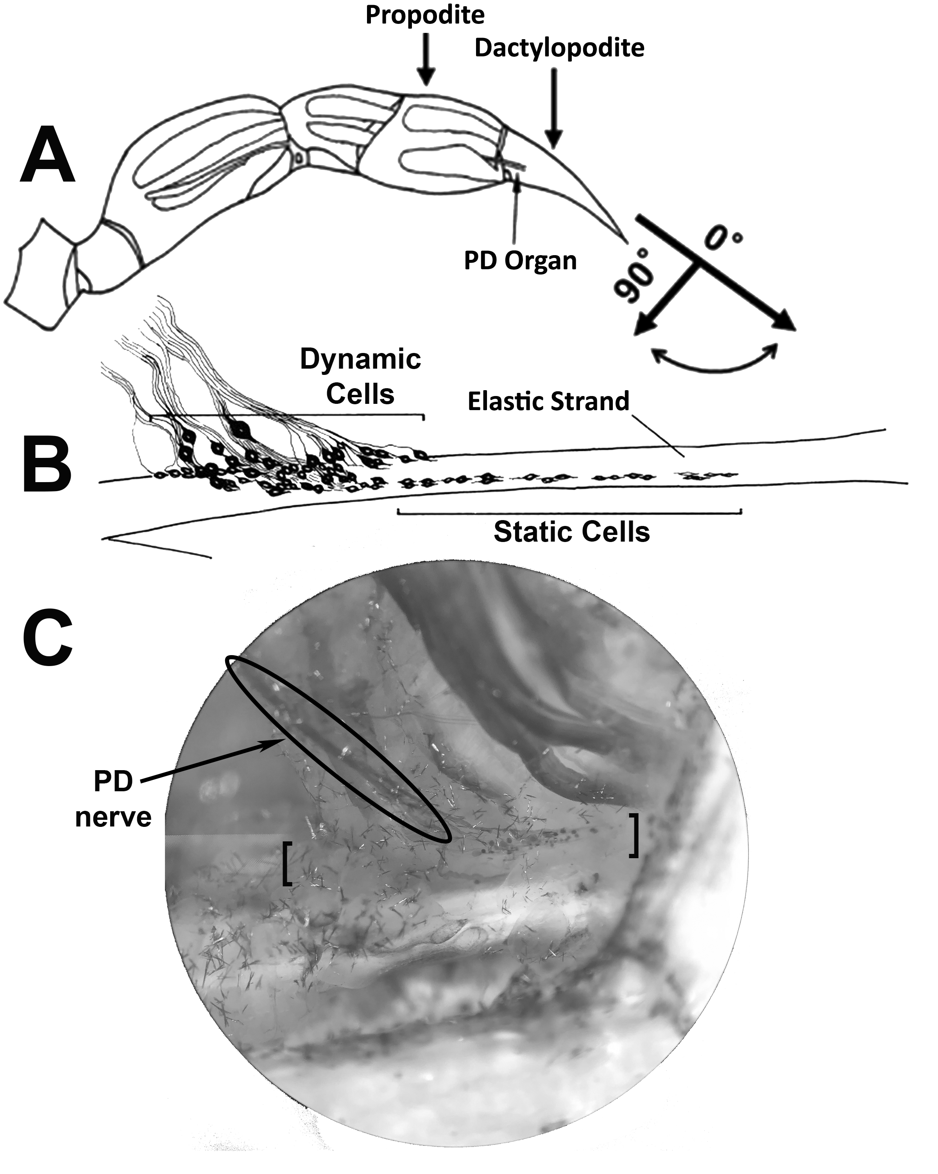
Figure 1. A. A schematic diagram of the first walking leg of the blue crab, Callinectes sapidus, containing the propodite-dactylopodite (PD) chordotonal organ. B. An enlarged diagram of the dynamic and static cells of the PD nerve embedded in the elastic strand. C. A view of the PD organ stained with 0.05% solution of methylene blue. The brackets enclose the length of the elastic strand where the dynamic and static cell bodies are embedded.

Crayfish muscle receptor organ (MRO)

The dissection and recording procedures are described in Leksrisawat et al., (2010). In brief, the isolated crayfish abdomen was placed in a Sylgard-lined dish filled with crayfish saline (Figure 2A). The MRO was moved using a wooden dowel from a relaxed position to a stretched position in a one-second time frame, held for 10 seconds, and then moved back to the starting position. An insect dissecting pin was used to mark the displacement range, and each displacement was marked on the computer recording file. The segmental nerve to the segment of interest is pulled into a suction electrode for recording the extracellular spikes (Figure 2A and B).

The displacement rates were the same as for the crab PD organ. The crayfish saline used was a modified Van Harreveld’s solution (in mM: 205 NaCl, 5.3 KCl, 13.5 CaCl2ꞏ2H2O, 2.45 MgCl2ꞏ6H2O, and 5 HEPES adjusted to pH 7.4).

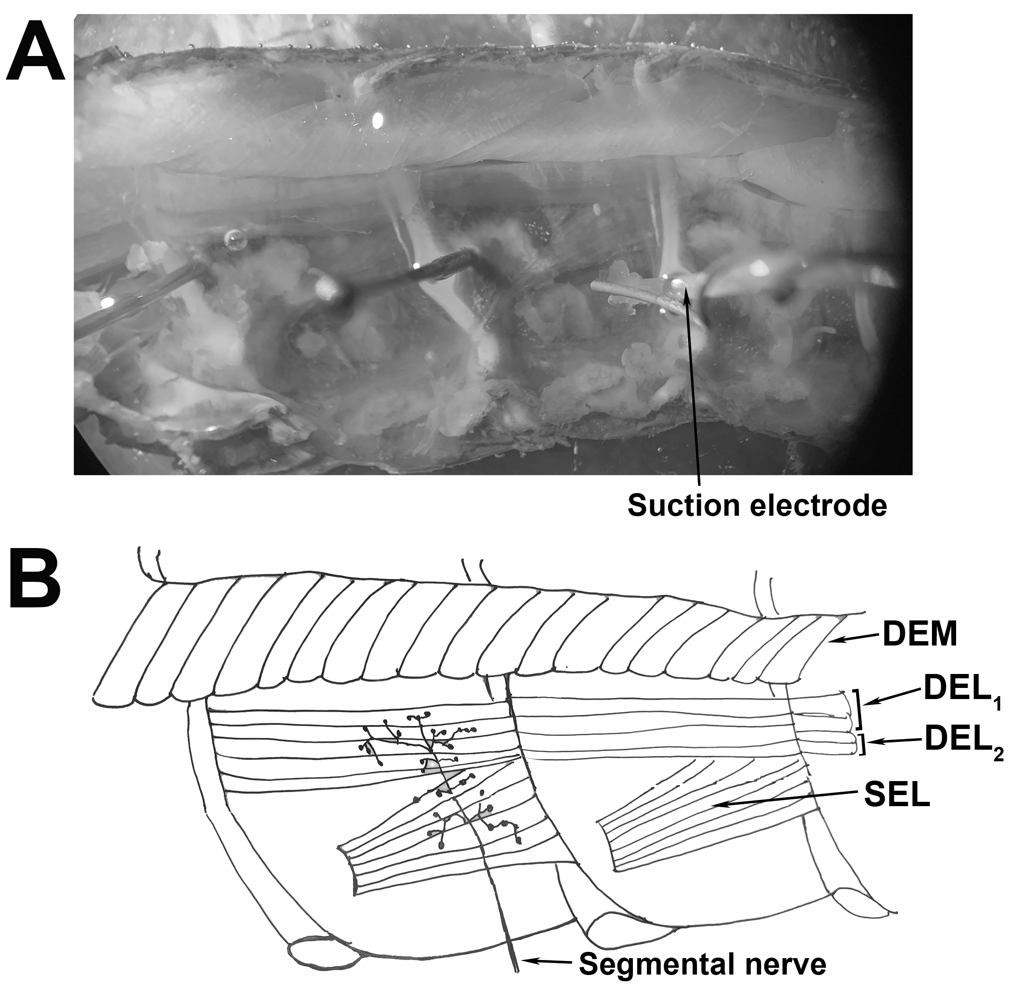
Figure 2. A. A hemi-section of the crayfish abdomen viewed from ventral to dorsal after removal of the ventral muscle. The segmental nerve containing the nerves associated with the MRO is taken up by a suction electrode. B. A schematic diagram of the preparation seen in A with muscles labeled. The deep extensor muscles (DEL1, DEL2, and DEM) and the superficial lateral extensor muscle (SEL) are labeled. The MRO organ is beneath the DEL1 muscle alongside to the DEM.

The crayfish walking leg opener neuromuscular preparation

The dissection and recording procedures are described in Cooper and Cooper (2009). In brief, the ventral cuticle of the propodite and the closer muscle is removed to expose the ventral surface of the opener muscle in the propodite cavity (Figure 3A). The cuticle over the flexor muscle in the meropodite segment is removed. The apodeme (tendon) at the meropodite - carpopodite joint is cut for the flexor exposing the extensor muscle and the leg nerve. The main leg nerve and the extensor muscle are exposed so the most dorsal branch of the main leg nerve in the proximal end of the meropodite segments contains the excitatory motor neuron to the opener muscle. This nerve branch is then pulled into a suction electrode for stimulation.

To evoke action potentials in the excitatory axon it is selectively stimulated by a Grass stimulator. The distal muscle bundles (Figure 3B) were impaled with a sharp intracellular electrode (20 to 30 mOhm resistance) filled with 3 M KCl. The excitatory junction potentials (EJPs) were recorded from the muscle fiber of interest. Short-term facilitation (STF) in the EJPs was obtained by stimulating at 40 Hz for 25 stimuli within a train and repeated every 250 milliseconds. To record action potentials within the excitatory motor neuron, a microelectrode was placed into the excitatory axon of the opener muscle close to the axon bifurcation (Figure 3 A, B)(He et al., 1999). A standard head stage and amplifier for intracellular recording of the muscle and axon was used (Axonclamp 2B, and 1 X LU head stage, Molecular Devices, Sunnyvale, CA, USA). The crayfish saline used was the same as described above for the MRO preparation.

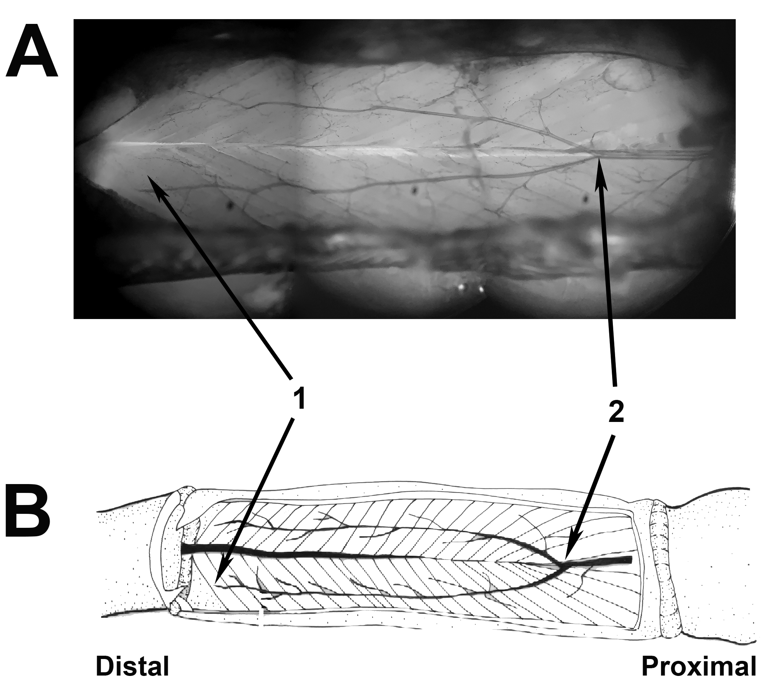
Figure 3. A. A view of the crayfish walking leg opener muscle and axon stained with 0.05% solution of methylene blue. B. A schematic diagram of the preparation seen in A. The muscle excitatory junction potentials were recorded from the distal muscles of the preparation, marked as ‘1’ in the figure. The axon recordings were taken from the ‘Y’ portion of the axon towards the proximal end of the preparation, marked as ‘2’ in the figure.

The larval Drosophila neuromuscular preparation

The dissection and recording procedures are described in Kurdyak et al., (1994) and
Li et al., (2001). In brief, the third instar Canton S larvae was used.
The common ‘wild-type’ laboratory strain of D. melanogaster, Canton S, was used in these studies. Early 3rd instars were developmentally staged so that all specimens were 50–70 h post hatching. Flies were maintained at room temperature (21–23 °C) on a 12-h light:dark cycle in vials partially filled with a cornmeal–agar–dextrose–yeast medium. The larval dissections were performed beginning with a longitudinal dorsal midline cut to expose the CNS. The segmental nerves were cut and one segmental nerve was sucked into a suction electrode filled with HL-3 saline and stimulated. Muscle 6 (m6) was utilized for intracellular recordings (Figure 4A and B). The EJPs were measured by intracellular recordings with a sharp glass electrode (3 M KCl) and AxoClamp-2 B amplifier. Preparations were used immediately after dissection. Electrical signals were recorded online to a computer via a PowerLab/4s interface (ADI Instruments, Colorado Springs, CO, USA). The segmental nerves were stimulated at 0.5 Hz (S88 Stimulator, Astro-Med, Inc., Grass Co., West Warwick, RI, USA). The modified HL3 saline was used for physiological measures at a pH of 7.1 (Stewart et al., 1994; de Castro et al., 2014). Saline solution (in mM): 1.0 CaCl₂·2H₂O, 70 NaCl, 20 MgCl₂, 5 KCl, 10 NaHCO₃, 5 trehalose, 115 sucrose, 25 5N, N-bis(2-hydoxyethyl)-2-aminoethanesulfonic acid (BES).

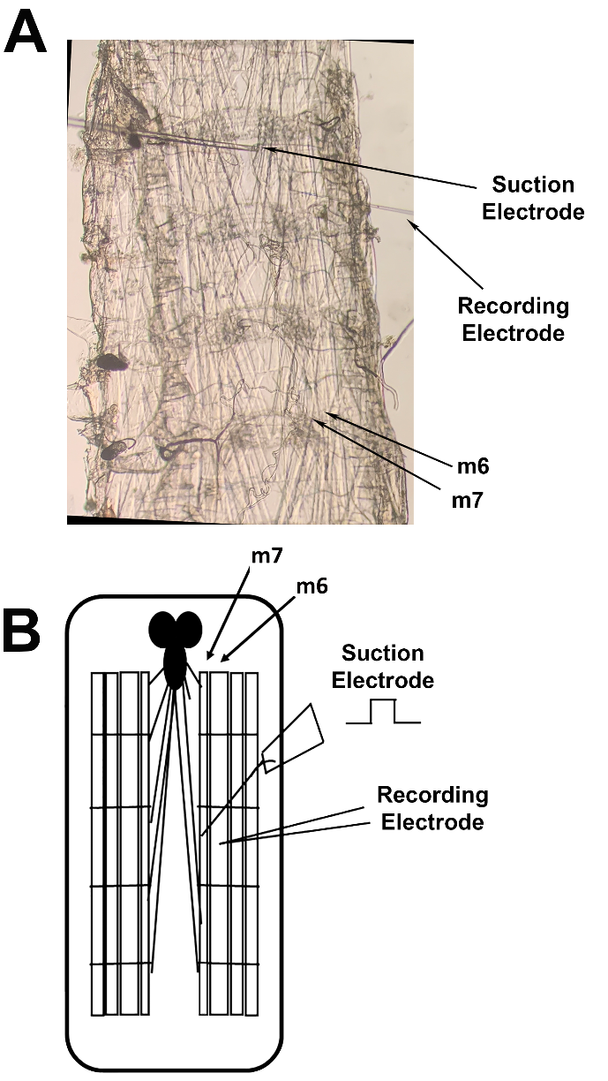
Figure 4. A. Dissection exposing the body wall muscles of a 3rd instar larva for recording synaptic responses in identifiable muscles. The synaptic excitatory junction potentials were initiated by stimulating the transected segmental nerve with a suction electrode. Recordings were obtained from the m6 muscle fiber with an intracellular electrode. B. A schematic diagram of A.

The larval Drosophila heart

The dissection and recording procedures are described in Cooper et al. (2009). In brief, the fileted larva preparations were dissected ventrally and pinned on four corners. Guts and visceral organs were removed, leaving the heart intact and still attached to the rostral and caudal ends of the dermis (Figure 5). Dissection time was 3–6 minutes. The preparation was allowed to recover in HL3 saline for 3–5 minutes after dissection. Heartbeats were counted in the caudal region of the heart by manual inspection through a dissecting microscope (de Castro et al., 2014). The bathing saline was exchanged to one containing MS-222 (0.1%) and the heart rate was counted again, followed by removal of the MS-222 and flushing the preparation with fresh saline and counting the heart rate after the washout.

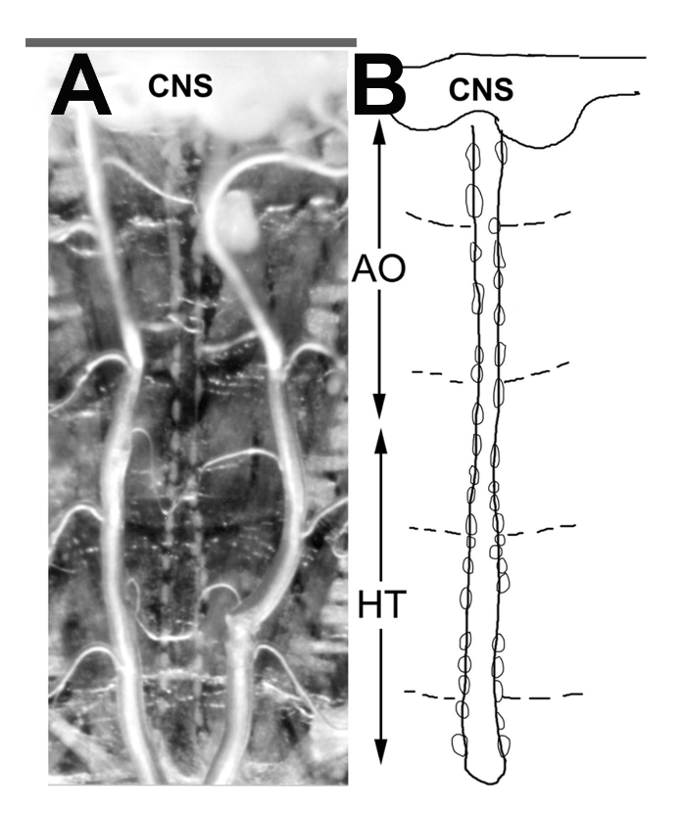
Figure 5. A. The filleted larva preparation for exposure of the heart to MS-222 and measuring heart rate. Larvae were dissected ventrally and pinned on four corners. Guts and visceral organs were removed leaving the heart intact and still attached to the rostral and caudal ends of the dermis. The preparation was allowed to recover in HL3 saline for 3–5 min after dissection. Heartbeats were counted by manual inspection through a dissecting microscope before and after switching to the compound of interest. Third instar larva were used. Heart rates were measured from the caudal end of the preparation close to where the two tracheal tubes come together. B. A schematic diagram of A outlining the heart (HT) and the aorta (AO).

Data analysis
The analysis of the electrical signals from the PD was processed by measuring the number of spikes within the first second, which covered the dynamic movement of the joint to the stretched position. The stretched position was then held for another ten seconds. The eight seconds following the initial one second of dynamic activity were used to measure the activity of the static position-sensitive neurons as indicated in Figure 6. Three trials were performed for each time point. The activity from the set of three trials was averaged for each time point for both the one and eight second activity measures. Measures were made during initial saline exposure, after 15 minutes of exposure to MS-222, and after 20 minutes of a saline washout. Control experiments were performed with exchange of saline to saline without MS-222 for the same time periods and the data is presented in previous reports (Stanback et al., 2019).
The analysis of the electrical signals from the MRO was processed by measuring the number of spikes within the first 10 seconds of activity, which included the one second of dynamic activity as the MRO was stretched and an additional 9 seconds of static activity.
The rank sum pairwise test or a sign test was used to compare the differences in responses before and after exchanging solutions. In some cases, synaptic responses were non-existent with exposure to MS-222 which did not allow for parametric analysis. The analysis was performed with Sigma Stat software. A p of ≤0.05 was considered statistically significant. To examine the consistency and reproducibility of data analysis, comparisons in analysis among different participants blind to the experimental conditions were performed on some of the same data sets.

Results
Crab chordotonal organ

A representative preparation of the crab PD organ illustrates the robust dynamic activity within the first second of joint movement (Figure 6A1). After being held in a static position of leg extension the dynamic activity returns when the joint is moved back to the original flexed position. The static activity is monitored over the next 8 seconds after the initial one second dynamic activity from extending the joint. This activity generally shows some accommodation over time. The dynamic (one second) and static (eight second) activity both substantially decreased after incubation for 15 minutes in MS-222 (0.1%) (Figure 6A2). Twenty minutes after removal of MS-222 by washing out the preparations with three fresh saline exchanges and flushing the saline around the preparation, the dynamic and static activity gradually returns (Figure 6A3). Averaging the three repetitive trials for each exposure (initial saline, exposure to MS-222, and saline wash) for the 6 preparations demonstrates the trend that MS-222 decreases the neural activity for both the dynamic and static activity (Figure 6 B and C; N=6, p < 0.05 non-parametric Sign test).

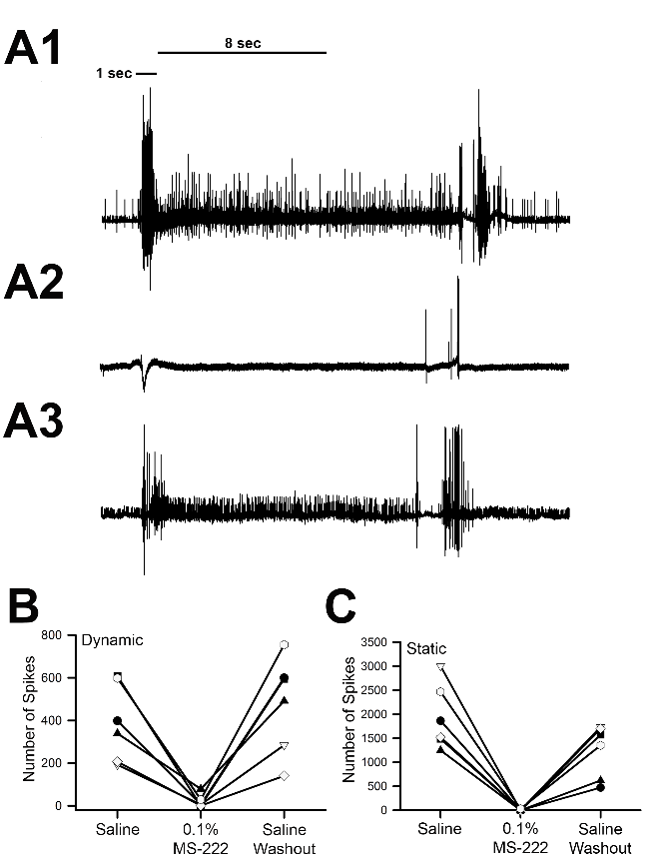
Figure 6. A1. Representative trace of the extracellular one second dynamic and eight second static activity of the PD nerve in saline while extending the joint to the fully extended position and held statically for more than 10 seconds prior to returning the joint to its starting position. A2. Representative trace of the extracellular one second dynamic and eight second static activity of the PD nerve in MS-222 (0.1%) while moving the limb from a flexed to extended position. A3. Representative trace of the extracellular one second dynamic and eight second static activity of the PD nerve after three saline washouts with the same movement paradigm as A and B. The traces are longer than 8 seconds to ensure that static activity is captured prior to returning the joint to the starting position B. The mean number of spikes for the extracellular one second dynamic activity for each PD organ preparation in saline, after 15 minutes of incubation in MS-222 (0.1%), and 20 minutes after three saline washouts. C. The mean number of spikes for the extracellular eight second static activity for each PD organ preparation in saline, after 15 minutes of incubation in MS-222, and 20 minutes after three saline washouts. The MS-222 had a significant effect in reducing the neural activity for both the dynamic and static sensitive neurons (N=6, p<0.05, non-parametric Sign test).

Crayfish muscle receptor organ (MRO)

A representative preparation of the crayfish MRO illustrates the activity within the abdominal joint movement (Figure 7A1). After being held in a static position for 10 seconds the joint is returned to the original position. Given that the MRO is comprised of only two neurons, there is not a recruitment of additional neurons as is the case for the crab PD organ. The dynamic and static activity was analyzed together over 10 seconds. The 10 seconds included the one second of movement to the static position and nine seconds of holding at the stretched position (Figure 7A). The neural activity substantially decreased after incubation for 15 minutes with MS-222 (0.1%) (Figure 7A2). Twenty minutes after removal of MS-222 by washing out the preparations with three fresh saline exchanges and flushing the saline around the preparation, the activity gradually returns (Figure 7A3). Averaging the three repetitive trials for each exposure (initial saline, exposure to MS-222, and saline wash) for the 6 preparations demonstrates the trend that MS-222 decreases the neural activity (Figure 7B; N=6, p<0.05, non-parametric Sign test).

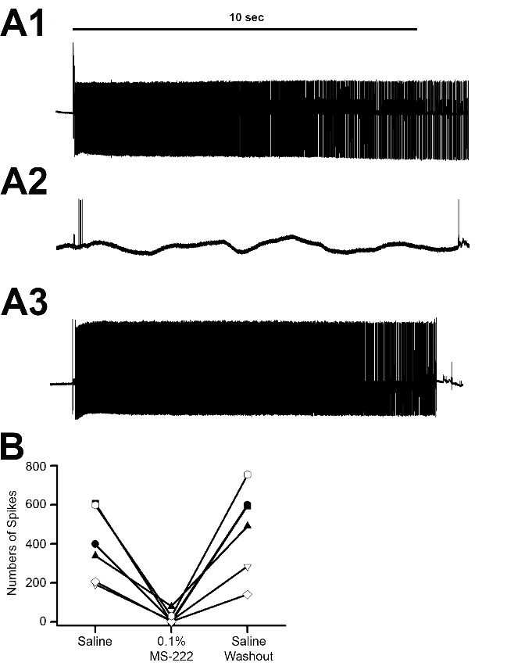
Figure 7. A1. Representative trace of the extracellular ten second activity of the MRO segmental nerve in saline. A2. Representative trace of the extracellular ten second activity of the MRO segmental nerve after a 15 minute incubation in MS-222 (0.1 %). A3. Representative trace of the extracellular ten second activity of the MRO segmental nerve 20 minutes after after three saline washouts. B. The mean number of spikes for the ten second activity for each MRO preparation in saline, after 15 minutes of incubation in MS-222, and 20 minutes after three saline washouts. The MS-222 had a significant effect in reducing the neural activity (N=6, p<0.05, non-parametric Sign test).

The crayfish walking leg opener neuromuscular preparation

The evoked EJPs responses on the opener muscle rapidly facilitate with repetitive stimulation as illustrated in a representative preparation (Figure 8A). The amplitudes of the EJPs tend to reach a plateau by the 25th stimuli when the nerve is stimulated at 40 Hz (Crider and Cooper, 2000; Desai-Shah et al., 2008). Thus, the amplitude of the 25th EJP within the stimulus train is used for assessment for the effect of MS-222 on synaptic responses. Within 20 minutes of incubation in saline containing MS-222 (0.1%) the responses are greatly attenuated, but return after exchanging and flushing the preparation with fresh saline not containing MS-222 (Figure 8B). A similar trend was observed for all 6 preparations (Figure 8C; N=6, p<0.05, paired T-test).

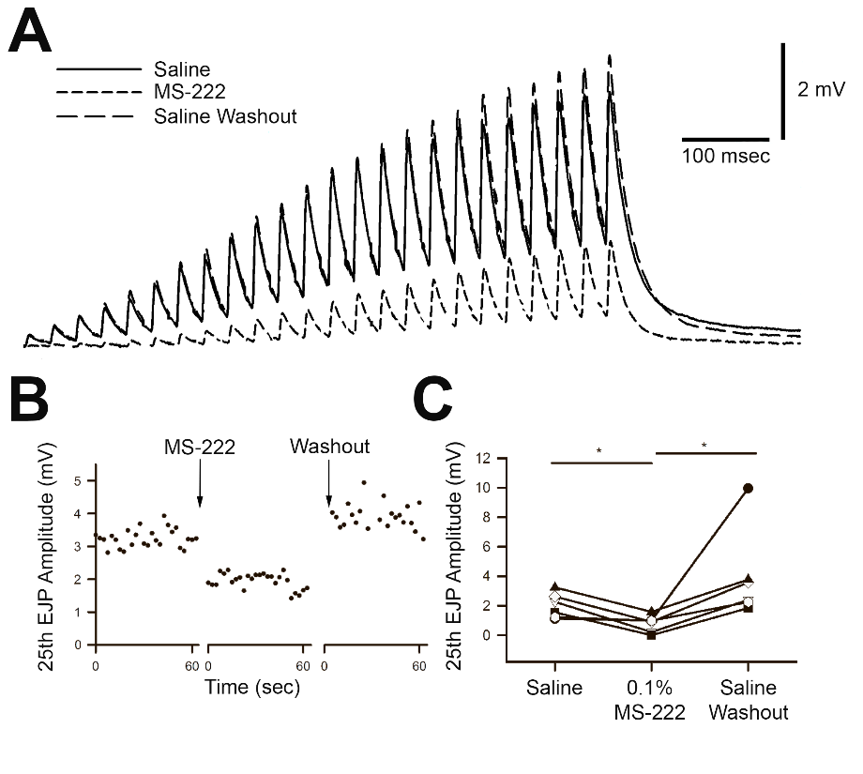
Figure 8. A. Representative traces of the excitatory junction potentials (EJPs) recorded with an intracellular electrode from the distal muscle fibers in opener muscle of a crayfish walking leg. The responses show a marked facilitation that occurs throughout the stimulation train delivered at 40Hz for 25 stimuli. The responses are shown before and during MS-222 exposure (0.1%) as well as after exchanging the bathing media with fresh saline to remove the MS-222.
B. The 25th EJP amplitudes (mV) for a representative opener muscle preparation in saline, after 15 minutes of incubation in MS-222, and 20 minutes after three saline washouts. C. The mean 25th EJP amplitude (mV) for each opener muscle preparation in saline, after 15 minutes of incubation in MS-222, and 20 minutes after three saline washouts. (N=6, p<0.05, paired T-test; * indicates a significant difference).

The action potential within the excitatory motor neuron innervating the opener muscle is depressed after exposure to MS-222 (0.1%); however, the amplitude returns after removing MS-222 as shown for a representative preparation (Figure 9A). This same trend occurred for all 6 preparations (Figure 9B; N=6, p<0.05, non-parametric Sign test).

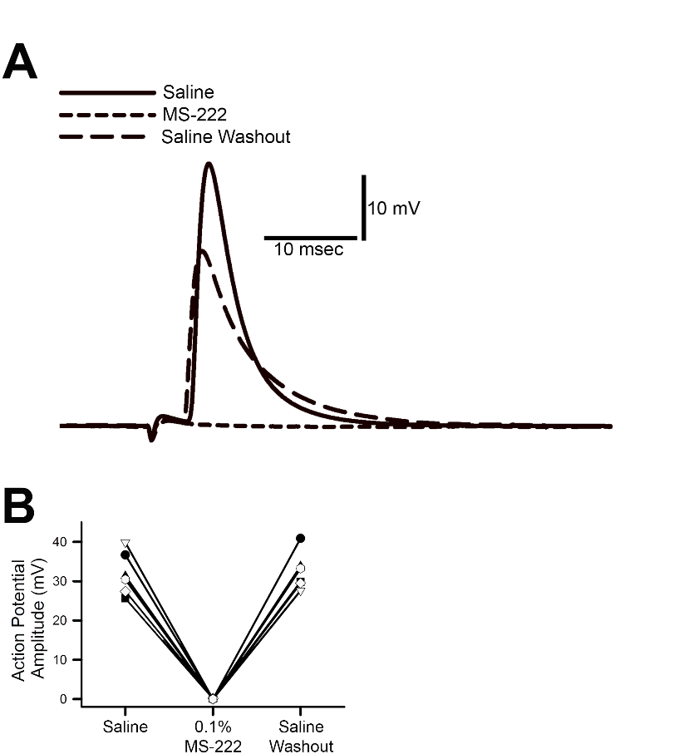
Figure 9. A. A representative trace of the action potential from the excitatory motor neuron to the opener muscle in saline, after 15 minutes of incubation in MS-222, and 20 minutes after three saline washouts. An average of 5 responses in each condition was used. B. The mean action potential amplitudes (mV) for each preparation in saline, after 15 minutes of incubation in MS-222, and 20 minutes after three saline washouts. (N=6, p<0.05, non-parametric Sign test).

The larval Drosophila neuromuscular preparation

The EJPs recorded on m6 of 3rd instar larval preparations showed a similar trend as for the crayfish opener neuromuscular junction in being depressed by exposure to MS-222 (0.1%), as shown in a representative preparation (Figure 10A and B). The synaptic innervation on m6 is of higher output, recruiting more synaptic vesicles to fuse than for the crayfish opener muscle (Atwood and Cooper, 1996). The EJP responses are thus robust enough such that they are not required to facilitate to obtain good measures of the EJP amplitude. Thus, only a single stimulus at 0.5 Hz is sufficient to measure EJP responses. This same trend occurred for all 6 preparations (Figure 10C; N=6, p<0.05, paired T-test; * indicates a significant difference).

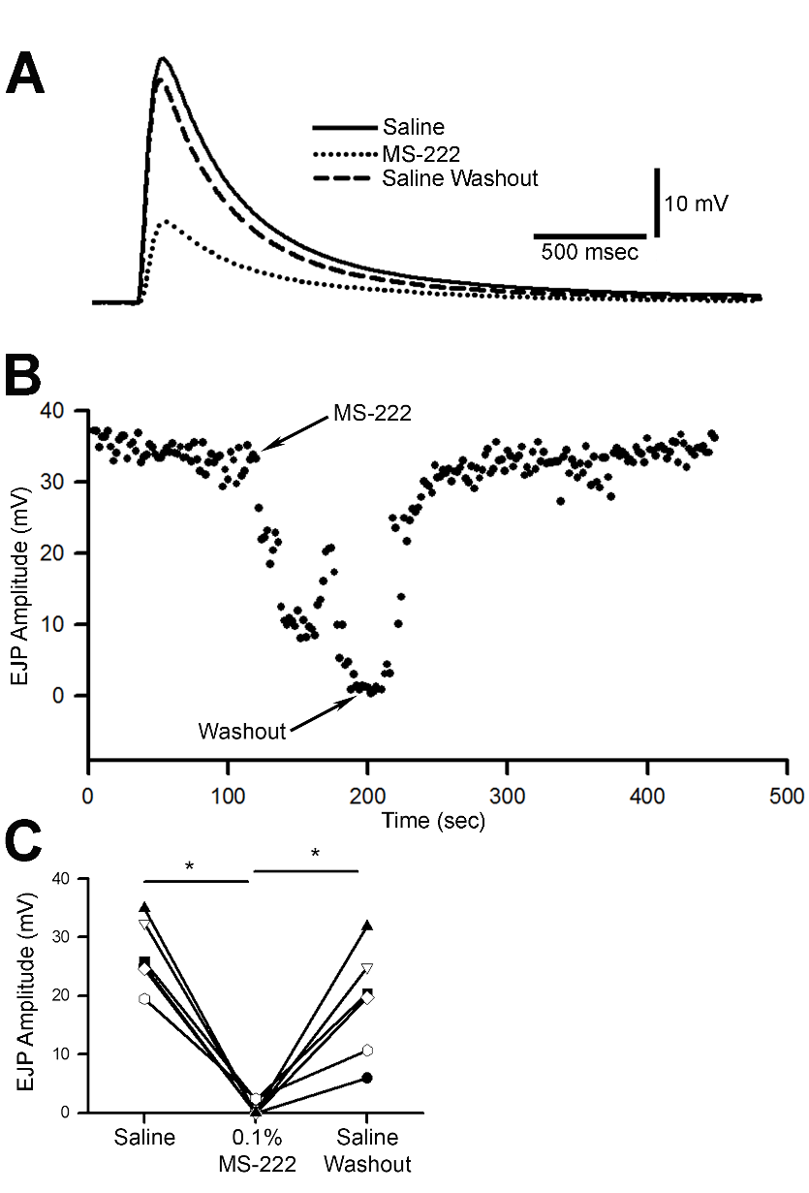

Figure 10. A. Representative traces of the excitatory junction potentials (EJPs) recorded with an intracellular electrode from m6 muscle in saline, during exposure to MS-222 (0.1%), and after three saline washouts. B. The EJP amplitudes (mV) for a representative larval NMJ preparation in saline, upon exposure to MS-222, and after three saline washouts. Stimulations were delivered at 0.5 Hz. C. The mean EJP amplitude (mV) for each fly NMJ preparation in saline, after incubation with MS-222, and after three saline washouts (N=6, p<0.05, paired T-test; * indicates a significant difference).

The larval Drosophila heart

The larval heart also showed sensitivity to MS-222 (0.1%), as the heart stopped beating when exposed to the compound. The heartbeat returned following the removal of MS-222 and flushing the preparation with fresh saline. This same trend occurred for all 6 preparations (Figure 11; N = 6, p < 0.05 non-parametric Sign test).

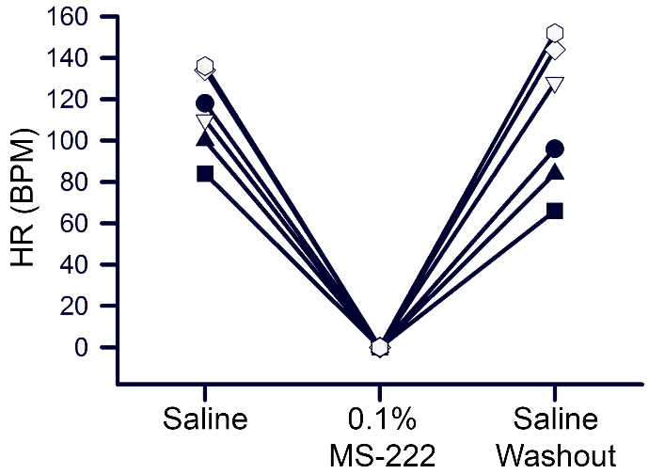
Figure 11. The heart rate for each larval preparation in saline, exposure to MS-222 (0.1%) and after three saline washouts without MS-222. (N=6, p<0.05, non-parametric Sign test).

Reproducibility in analysis of data sets

Analysis of the number of spikes of the crab PD and crayfish MRO with various participants in a classroom setting illustrated that similar outcomes were obtained. The approach for counting the spikes was presented to the class such that the crab PD preparations needed to be broken into sections of the first second and the following eight seconds for analysis. The class was informed to analyze the entire 10 seconds of the MRO data sets. They were not informed as to what the data sets represented regarding experimental treatment. The analysis of different participants is compared with different symbols for the same set of data for the crab PD and crayfish MRO preparations for the different conditions. Two different preparations of recorded spikes for both the crab PD and crayfish MRO were used. The number of spikes in each data set was averaged for the three trials as presented above for the preparations. Here the data is not given in order of the experimental procedure as the participants only were given data sets to analyze. The analysis is compared for three independent groups of participants for each data set. The reproducibility….. blah blah…(Figure 12).

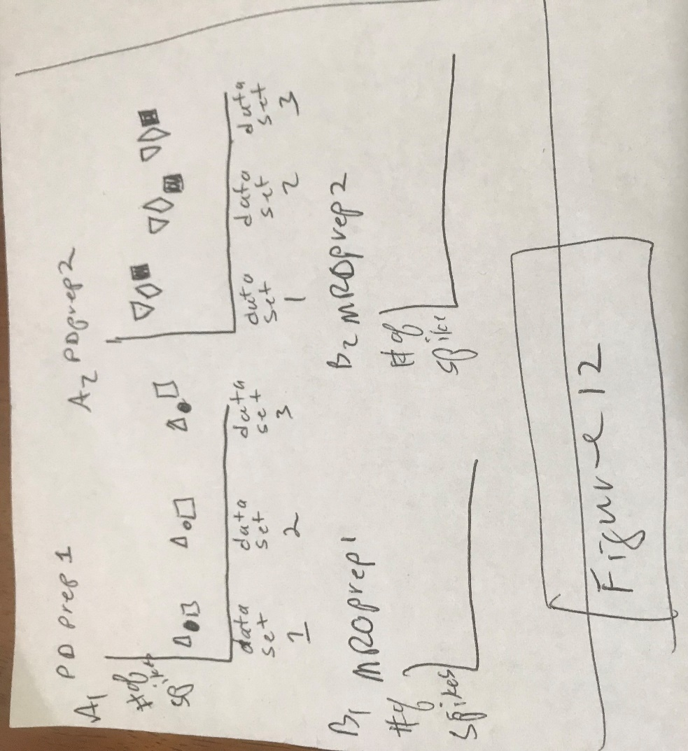

All 14 participants in the class setting also applied MS-222 to larval hearts and washed out MS-222 to make their own observations of the effect on heart rate. All 14 participants concurred that MS-222 stopped the heartbeat and that flushing the preparations with saline returned the heart to beating again. {of course this might change depending on the class results}.

DISCUSSION
- 1st paragraph….. This study demonstrated that MS-222…….recap that main findings.
-2nd…. The PD and MRO as primary sensory neurons being a indication that sensory input in other sensory system in likely attenuated with MS-222. And that the response can be recovered but that with 0.1 % MS-222 flushing of the tissue is required to regain function.
-3rd -differences in the NMJs of the crayfish opener and the fly NMJ. The larval NMJ is very exposed relatively on the surface of the single muscle fibers as compared to the muscle fiber which are housed within bundles composed of multiple fibers for the crayfish preparation (refs).
-4th the in situ Larval heart tube preparation is very exposed to the compound in the bathing saline and is rapidly affected by the MS-222 as soon as it is applied, similar to the larval NMJ. Ref here literature which suggests no Na channel on larval heart… (ref). Considering the larval heart is assumed not have an involvement of voltage gated sodium channels for the pacing it is not yet established how MS-222 stops the pacing activity. This remains to be further investigated as possible the larval heart has a different isoform of the sodium channel not detected by the ….. (approach used in above paper). Perhaps MS-222 at 0.1 % may have an effect on other ionic channels associated with the pacing of the larval heart as alteration in Ca2+ flux through calcium channels or the NCX exchanger as well as the plasma membrane calcium pump will affect the heart rate (refs).
- The reduction in the amplitude of the action potential recorded with intracellular electrodes within the axon of the opener neuromuscular preparation is convincing that the voltage gated sodium channels are blocked since the amplitude diminishes and can not be evoked. However, the amplitude in the action potential would gradually return followed exchange the MS-222 out of the bathing saline. This supports the finding is ….see literature on MS-222 in fish and other critters….. that MS-222 is blocking voltage gated sodium channels as the mechanism of action in reducing movements of the animal and behaving as other anesthetics such as procaine etc…….. need to dig into literature.

- Upon investigating for other studies and published reports of the use of MS-222 in insects and crustaceans only scant reports appear…. One on that little Limpet and any on insect ??
However, statements such as " find quote" MS-222 does not appear to wor well for crustaceans appear but without presenting any experimental evidence.

- in this study, exposed in situ preparations were used for examining the direct effect on neurons and cardiac function in model invertebrate preparations. These preparation are also common ones used for experimental procedures in neurobiology and physiology (refs). The species of crab and crayfish used in this study are also of commercial importance as eatable crustaceans. The use of MS-222 for transport of these animals for for euthanasia prior to slaughter for food source may not be feasible as the MS-222 may remain in the tissue after slaughter. Given that 0.1% MS-222 did wash out and the activity returned in neurons and cardiac tissue is promising. However, an anesthetized crustacean would need to be able to circulate the hemolymph and have respiratory function (i.e. gills) to likely remove the compound. Such whole animals' experiments are needed and to examine the retention of MS-222 in tissue if to be used for animal or human consumption. Future studies in varying the dosage in exposure to whole animals or injection into animals as well as in isolated preparations could help in establishing if MS-222 could be more widely utilized for a variety of purposes.
The investigation of authentic scientific investigations with participating students in a classroom setting is a trend which is being promoted to exposure students to research as a group. This ACURE (authentic course-based undergraduate research experiences; Malloy et al., 2017; Stanback et al., 2019; Wycoff et al., 2018) approach builds on the CURE (course-based undergraduate research experiences) philosophy (Linn et al. 2015, Bakshi et al. 2016); however, aids is students undergoing a more complete research experience. In addition, utilizing participants within a course setting to analyze data sets blind to the experimental conditions provides an additional level for ??? {can't think of the word} for assessment in the accuracy of analysis and interpretation of the findings.

ACKNOWLEDGMENTS
Funded by Dept. of Biology, Univ. of KY. and by an Institutional Development Award (IDeA) from the National Institute of General Medical Sciences of the National Institutes of Health under grant number P20GM103436 (R.A.)

REFERENCES

Brodbelt David C (2009). "Perioperative mortality in small animal anaesthesia". Veterinary Journal (London). 182: 152–161.
Gaynor, J. S.; Dunlop, C. I.; Wagner, A.E.; et al. (January 1999). "Complications and mortality associated with anesthesia in dogs and cats". Journal of the American Animal Hospital Association. 35 (1): 13–17. doi:10.5326/15473317-35-1-13. PMID 9934922.

Atwood, H.L. and Cooper, R.L. (1996) Assessing ultrastructure of crustacean and insect neuromuscular junctions. Journal of Neuroscience Methods 69:51-58

Cooper, A.S., and Cooper, R.L. (2009) Historical view and demonstration of physiology at the NMJ at the crayfish opener muscle. Journal of Visualized Experiments (JoVE). JoVE. 33. http://www.jove.com/index/details.stp?id=1595; doi: 10.3791/1595.

Cooper, A.S., Rymond, K.E., Ward, M.A., Bocook, E.L. and Cooper, R.L. (2009) Monitoring heart function in larval Drosophila melanogaster for physiological studies. Journal of Visualized Experiments (JoVE). 32: http://www.jove.com/index/details.stp?id=1596

Crider, M.E. and Cooper, R.L. (2000) Differential facilitation of high- and low-output nerveterminals from a single motor neuron. Journal of Applied Physiology 88: 987-996

Desai-Shah, M., Viele, K., Sparks, G., Nadolski, J., Hayden, B., Srinivasan, V.K., and Cooper, R.L. (2008). Assessment of synaptic function during short-term facilitation in motor nerve terminals in the crayfish. The Open Neuroscience Journal 2: 24-35.

He, P., Southard, R.C., Whiteheart, S.W. and Cooper, R.L. (1999) Role of alpha-SNAP in promoting efficient neurotransmission at the crayfish neuromuscular junction. Journal of Neurophysiology 82:3406-3416

Kurdyak P, Atwood HL, Stewart BA, Wu C-F. Differential physiology and morphology of motor axons to ventral longitudinal muscle in larval Drosophila. J Comp Neurol350: 463– 472, 1994.

Li, H., Harrison, D., Jones, G., Jones, D., and Cooper, R.L. (2001) Alterations in development, behavior, and physiology in Drosophila larva that have reduced ecdysone production. Journal of Neurophysiology 85:98-104.

Leksrisawat B, Cooper AS, Gilberts AB, Cooper RL (2010) Response properties of muscle receptor organs in the crayfish abdomen: A student laboratory exercise in proprioception. J Vis Exp 45: http://www.jove.com/index/details.stp?id=2323 doi:10.3791/2323

Stewart, B.A.; Atwood, H.L.; Renger, J.J.; Wang, J.; Wu, C.F. Improved stability of Drosophila larval neuromuscular preparation in haemolymph-like physiological solutions. J. Comp. Physiol. A 1994, 175, 179–191. [Google Scholar] [CrossRef]

de Castro, C.; Titlow, J.; Majeed, Z.R.; Cooper, R.L. Analysis of various physiological salines for heart rate, CNS function, and synaptic transmission at neuromuscular junctions in Drosophila melanogaster larvae. J. Comp. Physiol. A 2014, 200, 83–92. [Google Scholar] [CrossRef]

Majeed ZR, Titlow J, Hartman HB, Cooper R (2013) Proprioception and Tension Receptors in Crab Limbs: Student Laboratory Exercises. JoVE 80:e51050, doi:10.3791/51050

Wycoff, S., Weineck, K., Conlin, S., Grau, E., Bradley, A., Cantrell, D., Eversole, S., Grachen, C., Hall, K., Hawthorne, D., Kinmon, C., Ortiz Guerrero, P., Patel, B., Samuels, K., Suryadevara, C., Valdes, G., Ray, A., Fleckenstein, L., Piana, E., Cooper, R.L. (2018) Investigating potential effects of clove oil (eugenol) in model crustaceans. IMPLUSE pp. 1-21 https://impulse.appstate.edu/articles/2018/effects-clove-oil-eugenol-proprioceptive-neurons-heart-rate-and-behavior-model-crustac
Bakshi A, Patrick LE, Wischusen EW (2016) A framework for implementing course-based undergraduate research experiences (CUREs) in freshman biology labs. The Am Biol Teacher 78(6): 448–455.

Linn MC, Palmer E, Baranger A, Gerard E, Stone E (2015) Undergraduate research experiences: Impacts and opportunities. Science 347: 1261757.

